**SOGETI MOVIE SEARCH ENGINE APPLICATION**

**--------------------------------------------------------------------------------By Kaji Islam**

1. **How to run**

**Step1: Open project directory [SOGETI Movie Application /project code]**

**Step2: find index.html file and double click to open**

1. **Requirement :**

**Only internet connection because application used omdb API .**

1. **Technologies used :**

**HTML,Angularjs,** **bootstrap CSS to make Responsive design, JSON data from omdbapi.**

1. **Few screenshot :**

**1.Home Page/Search Page**

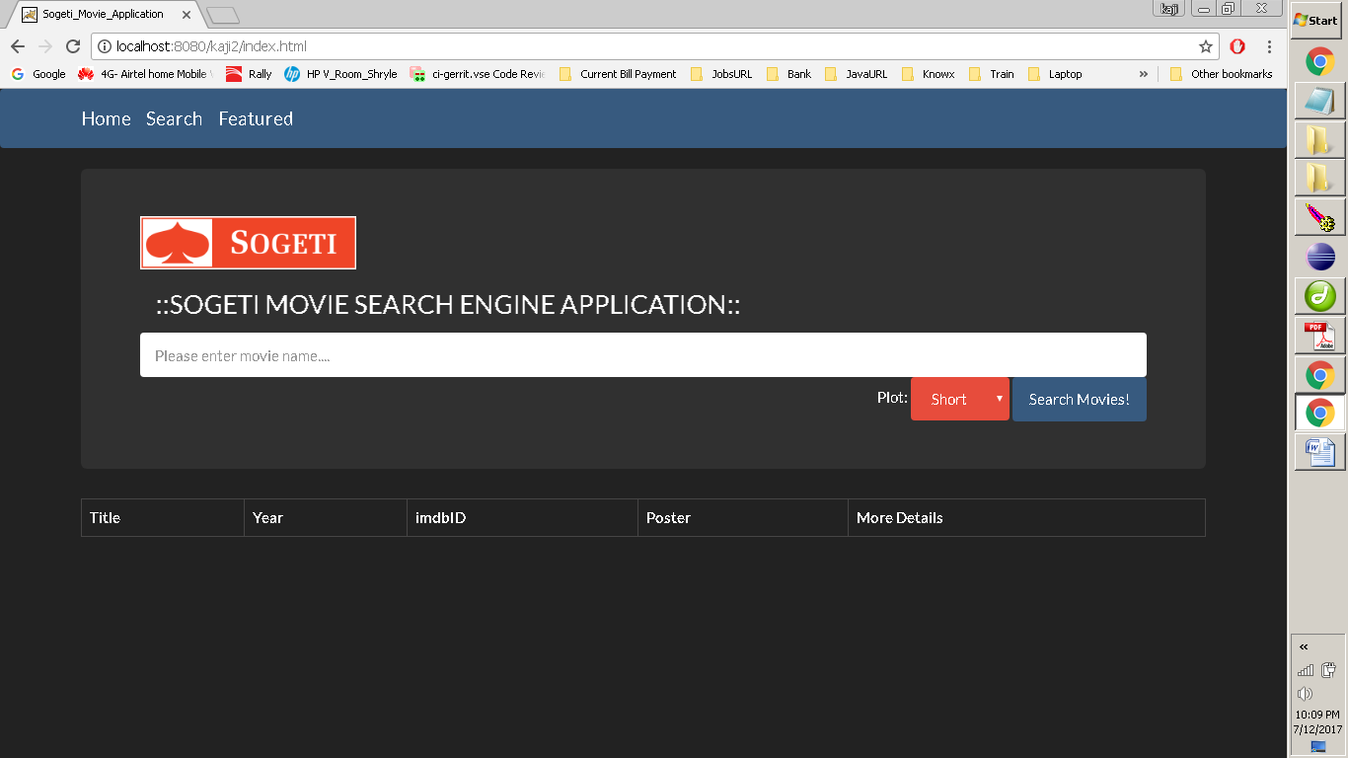

**2.Search movie**

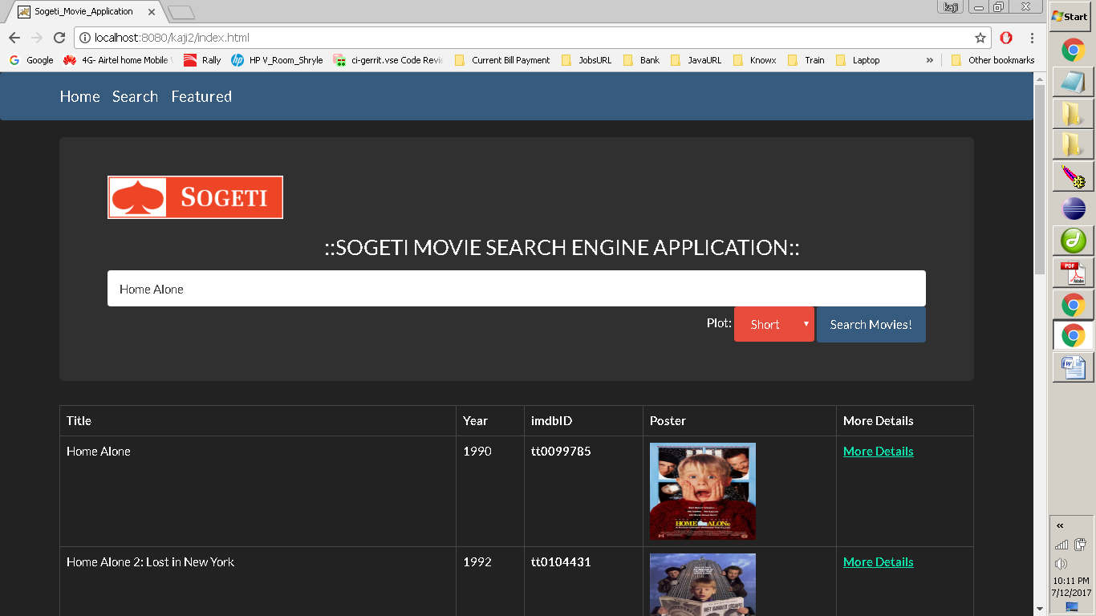

**3. More details page**

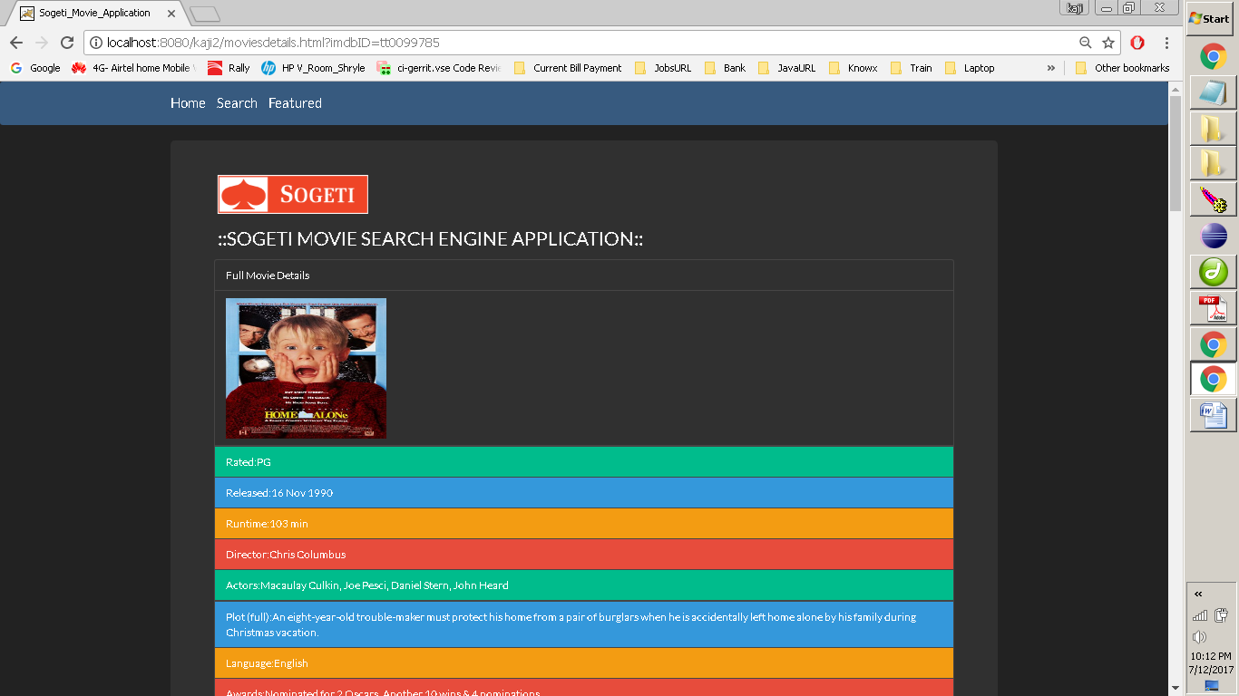

**4.** **Featured Page**

